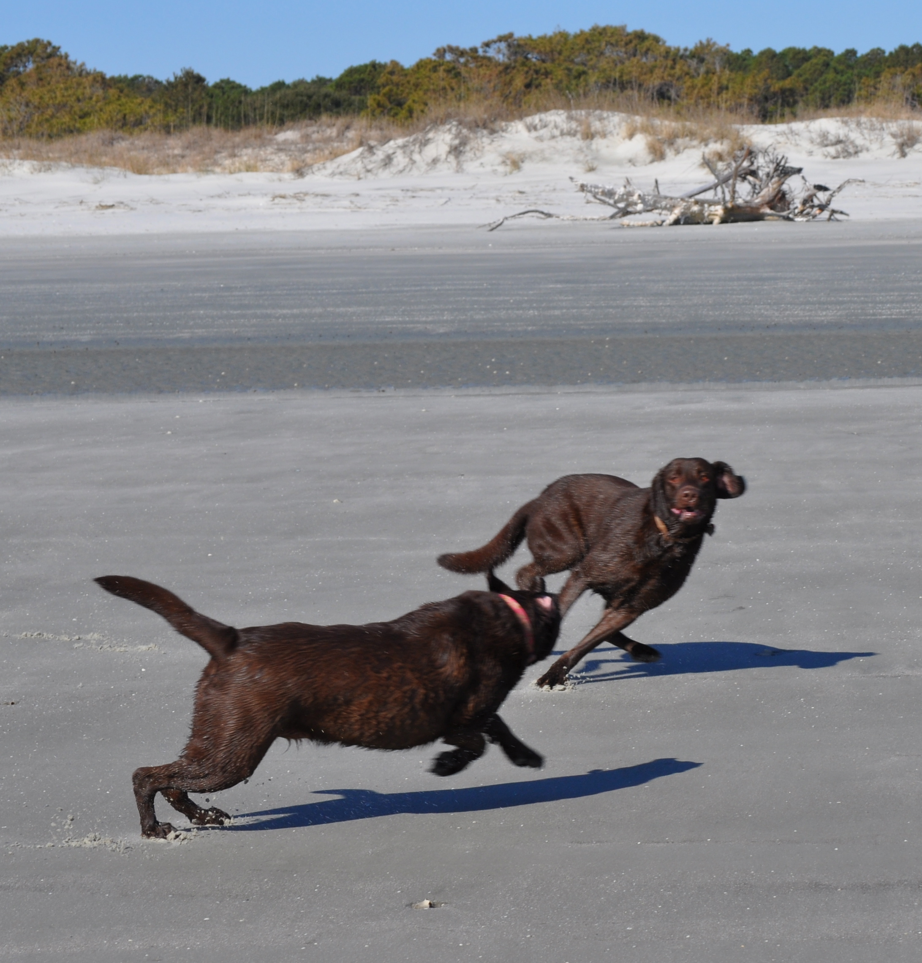
Dogs and the Sapelo Beach

Advice taken from Georgia Department of Natural Resources website
Shorebirds Dogs are effective predators and often disturb shorebirds that are nesting in the sand. Dogs can crush or eat young chicks or flush the parents off nests allowing other predators easy access to them. To minimize interactions with nesting birds keep your dog at home.
Do not allow your dog to chase birds on the beach. Several species of birds use Georgia beaches as critical stopovers during their long migrations. When forced to flee from dogs, birds expend extra calories and dip into their fat reserves. Chronic disturbance of resting birds can compromise their health and burns valuable energy needed for migration.
Sea Turtles From late spring through early fall; loggerhead sea turtles come to nest on Georgia's shores. Please take precautions to ensure your dog does not disturb adult turtles, their nests, or hatchlings. Do not allow your dog to dig above the high tide line and do not bring your pets to the beach after dark when females are laying eggs.
Encountering other dogs While we all like to think that our dogs are well mannered, it is important to remember that the canine social structure is quite different from that of humans. Anywhere that large numbers of dogs congregate the occasional fight is inevitable. Keeping your dog on a leash will minimize negative encounters with other dogs and give you better control of your pet if they are involved in a scuffle. Dogs with a history of aggression are best left at home.
Why do I need to pick up my dogs waste...won't the tide wash it away? The tide will wash it away...and that's the problem. Recently, dog waste on the beach has received a lot of attention. Not only is it unpleasant for beachgoers, but it also poses a very real health threat to swimmers and other dogs. Fecal bacteria in seawater, tied to dog waste on the beach, can make people and animals very ill. In some cases, these bacteria can reach levels that require the local Health Department to issue a swimmers' health advisory.
To ensure that your dog is not contributing to this problem, always clean up your dog's waste and deposit it in an appropriate trash receptacle.
How can I keep my dog safe at the beach? The American Kennel Club has provided the following guidelines to help you make your dogs trip to the beach an enjoyable one:
- When taking your dog to the beach, make sure there is plenty of fresh water and shade.
- Dogs can get sunburned just like humans, so limit your dog's exposure to the hot sun and apply a zinc-free sunblock to his ears and nose 30 minutes before going outside.
- Be careful not to let your dog spend too much time on hot sand or asphalt. Dogs can burn their feet just as easily as we can.
- Cool ocean water is very tempting to a dog. Don't allow your dog to drink too much seawater. This can cause diarrhea or vomiting and quickly dehydrate them.
- Check with lifeguards for daily water conditions. Dogs can be easy targets for jellyfish.
- Swimming is a great form of exercise for dogs, but don't let them overdo it. They will be using new muscles and may tire quickly.
- Running on a beach is strenuous exercise and a dog that is out of shape can easily pull a tendon or ligament. If your dog is out of shape, don't encourage him to run on the sand.
- The beach can present many hazards for your dog. Things to watch out for include boats, fishhooks, dead fish, garbage, and broken glass.
Salt and other minerals in ocean water can damage your dog's coat, so rinse him off at the end of the day.

